**Report Handout**

**Douglas Raymond 100904379**

The portion of the Vehicle I designed was the outer shell. The dimensions and the appearance were the most significant features to the sketches made. A modern and streamlined design was chosen, to appeal to an urban commuter. Each portion of the shell has been carefully considered as to fully optimize any available space.

Spring loaded gullwing doors (opening vertically on a frontal hinge) will be used further adding to the unique and futuristic appeal of the Vehicle.

The model will be shaped similar to that of a raindrop, as the natural shape of a raindrop travelling at terminal velocity has negligible air resistance, reducing *drag force*, thereby reducing the total effort required to move the Vehicle. The shape also considers the winter season and minimizes the collection of snow on the roof. Aerodynamics have been carefully considered by incorporating a curved roof, making sure the weight of the bicycle is efficient for the seasons and tasks required.

A partially covered rear wheel will be implemented as a completely covered rear wheel could result in excess snow buildup, during frigid weather conditions.

The dimensions of the Vehicle have been specifically tailored to the size of Canadian bike lanes, enough space has been provided to comfortably fit the user as well as incorporate additional safety features. Previously the dimensions of the Vehicle were 2.78m in length, 0.85m in width and 1.20m in height; to reduce the cost of materials and any excess weight that the user may have to carry the total length has been decreased to 2.4m as displayed below.

The appearance of the Vehicle will be customizable with various decal and paint modification options.  
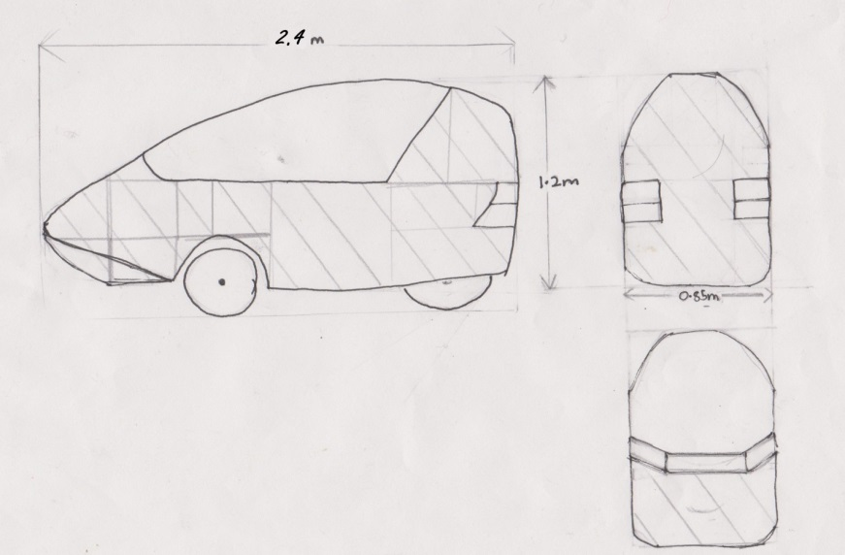

References:

1. <http://www.examiner.com/images/blog/wysiwyg/image/aerorider-01.jpg>

2. <http://www.solarwebsite.nl/wp-content/uploads/2009/07/20070802Aerorider1.jpg>

3. <http://www.nielsfries.de/wp-content/uploads/2010/12/Aerorider_011.jpg>

4. <http://www.aerorider.com/foto/aerorider/aerorider-04.jpg>

5. <http://i.usatoday.net/weather/resources/askjack/photos/rain-drop-big.jpg>

Figure Sketch of the Vehicle used in calculating surface area